Student’s name | …………………………………………………….…… | Grade | 7
Subject | Computer | Week No. | 4
Lesson Title | Data Transfer | Unit
Worksheet No. ( 4 )
Question A: write the correct name of each part. (P131)

Convert from decimal to binary
10000 | 1111101 | 110010000 | 1011000

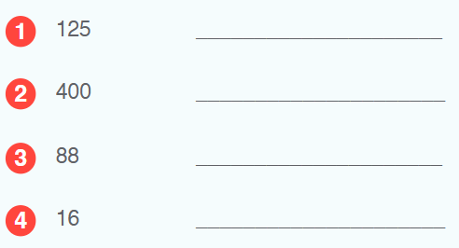
Good Luck

